SIMATS ENGINEERING (SAVEETHA SCHOOL OF ENGINEERING)
Department of Computer Science and Engineering
ASSESSMENT TOOL 2 – SCENARIO BASED ASSESSMENT (2 Questions)

Course Code: | ITA0502 | Course Title: | COMPUTER VISION
CO Assessed: | CO2 – Manipulation (BL3) | Assessment: | Assessment Tool 2 – Scenario Based Assessment
Weightage: | 20% of CIA | Total Marks: | 20 (2 Questions × 10 Marks)
CO5 Statement: | Apply image enhancement and segmentation techniques for extracting meaningful regions from images.(BL3)
Student Name: | Hemapriya. J | Reg. No.: | 192521431
Section / Batch: | SLOT C / 2025 | Date:

Code of Conduct
I Hemapriya. J (192521431) certify that this submission is my original work and that I have adhered to the guidelines specified for this assessment. I understand that any violation of academic integrity rules will result in disciplinary action.

Signature of the Student: Hemapriya.J

Instructions
- This test contains 2 questions, each carrying 10 marks. Total: 20 Marks.
- No negative marking. Unanswered questions carry zero marks.
- No calculators or electronic devices permitted.
- Duration: 60 minutes.

Section / Topic | Focus Area | Q. Nos. | Marks
Frequency Domain Image Enhancement | Periodic noise removal, Fourier Transform, notch filtering, quality inspection | 1 | 10
Spatial Filtering & Edge-Preserving Enhancement | Bilateral filtering, edge preservation, autonomous vehicle navigation | 2 | 10
GRAND TOTAL: |  | 20 Marks

Annexure A – Scenario Based Assessment

Scenario 1: Manufacturing Quality Inspection
An automated quality inspection system captures images of metal components. Electrical interference introduces repetitive horizontal stripes across the images, making defect detection unreliable.
(a) Interpret the scenario and identify the type of noise present.
(b) Explain how this degradation affects inspection accuracy.
(c) Recommend an appropriate enhancement technique to remove the interference.
(d) Justify why your selected approach is more suitable than spatial-domain methods.
(e) Explain your answer in a logical sequence.

Scenario 2: Autonomous Vehicle Navigation
A self-driving car captures road images during heavy rain. Although noise is present, the lane markings and road edges must remain sharp for safe navigation.
(a) Interpret the scenario and explain the challenge involved.
(b) Identify the importance of preserving edges while removing noise.
(c) Recommend a suitable filtering technique.
(d) Justify why your selected filter preserves important image details.
(e) Present your explanation clearly and systematically.

Rubrics for Calculation
Criteria | Weightage (%) | Level 4 (Exemplary) | Level 3 (Proficient) | Level 2 (Developing) | Level 1 (Beginning) | Marks
Understanding of Scenario | 20% | Demonstrates clear and complete understanding of the scenario and context | Shows good understanding with minor gaps | Partial understanding; misses key aspects | Misinterprets or fails to understand the scenario
Identification of Key Issues | 20% | Accurately identifies all relevant issues and factors involved | Identifies most key issues with minor omissions | Identifies limited issues; some irrelevant points | Unable to identify key issues
Application of Concepts | 25% | Applies appropriate concepts effectively to address the scenario | Applies concepts with minor errors | Limited or partially correct application | Unable to apply relevant concepts
Decision Making | 20% | Makes well-reasoned, logical decisions with strong rationale | Makes reasonable decisions with some justification | Makes weak decisions with limited justification | No clear decisions made or rationale provided
Clarity of Response | 15% | Response is clear, structured, and logically presented | Generally clear with minor issues | Somewhat unclear or poorly structured | Disorganized and difficult to understand

Faculty In-charge | Course Coordinator | Head of Department
Signature: _______________ | Signature: _______________ | Signature: _______________
Date: ___________________ | Date: ___________________ | Date: ___________________

Scenario 1: Manufacturing Quality Inspection

(a) Interpret the scenario and identify the type of noise present.
The automated quality inspection system captures images of metal components. Due to electrical interference, repetitive horizontal stripes appear across the images. This type of degradation is known as Periodic Noise (Sinusoidal Noise).
- Noise Type: Periodic Noise
- Cause: Electrical interference from power lines, sensors, or electronic equipment.
- Appearance: Regular horizontal bright and dark stripes repeated throughout the image.

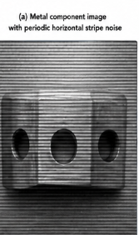

(b) Explain how this degradation affects inspection accuracy.
Periodic noise reduces the quality of the captured image and affects defect detection in several ways:
- Hides small defects such as scratches, cracks, and dents.
- Reduces image clarity and contrast.
- Produces false edges that may be detected as defects.
- Increases the possibility of incorrect classification.
- Decreases the overall reliability of the automated inspection system.

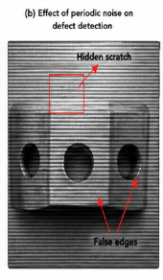

(c) Recommend an appropriate enhancement technique to remove the interference.
Recommended Technique:
Frequency Domain Filtering using a Notch Reject Filter
Working:
- Convert the image into the frequency domain using the Fourier Transform (FFT).
- Identify the bright frequency peaks corresponding to periodic noise.
- Apply a Notch Reject Filter to remove only those unwanted frequencies.
- Convert the image back to the spatial domain using the Inverse FFT.
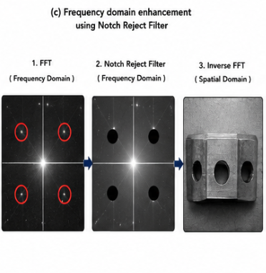

(d) Justify why your selected approach is more suitable than spatial-domain methods.
A Notch Reject Filter is more suitable because:
Frequency Domain (Notch Filter) | Spatial Domain Filters
Removes only periodic noise frequencies | Removes noise from the whole image
Preserves fine image details | May blur edges and defects
Maintains image sharpness | Reduces image quality
Highly effective for repetitive stripe noise | Ineffective against periodic interference
Since periodic noise appears as distinct frequency peaks, it can be removed precisely without affecting important image features.

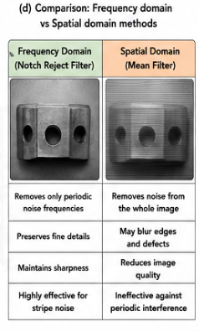

(e) Explain your answer in a logical sequence.
Step-by-Step Process
- Capture the image of the metal component.
- Electrical interference introduces periodic horizontal stripes.
- Convert the noisy image into the frequency domain using FFT.
- Detect the periodic noise frequencies.
- Apply a Notch Reject Filter to remove those frequencies.
- Perform the Inverse FFT.
- Obtain a clean image with preserved defects and edges.
- Use the enhanced image for accurate defect detection.

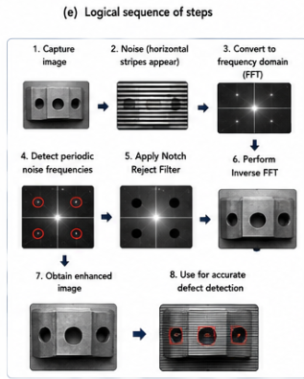

Conclusion
Periodic horizontal stripe noise caused by electrical interference is best removed using a Frequency Domain Notch Reject Filter, as it selectively removes interference while preserving important defect information required for accurate quality inspection.

Scenario 2: Autonomous Vehicle Navigation


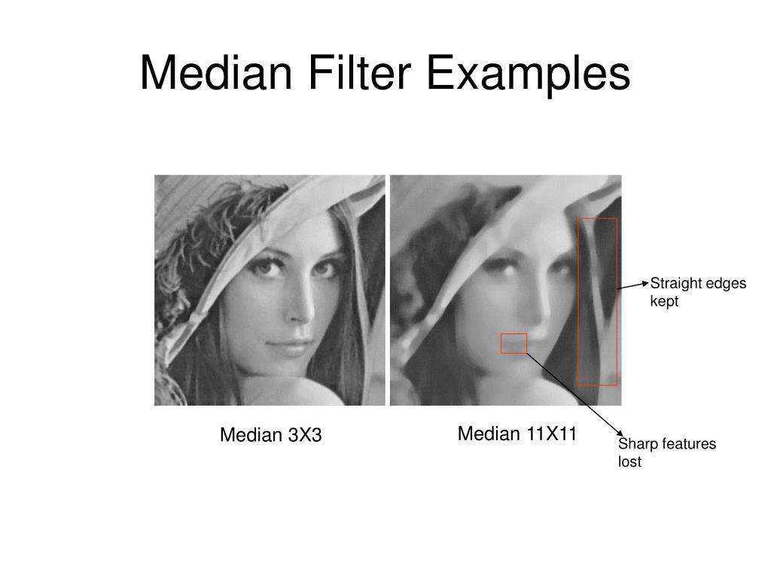
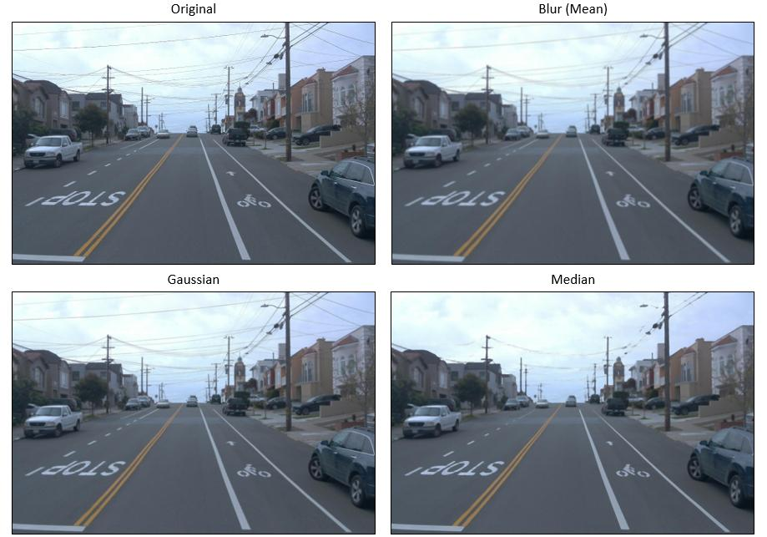

(a) Interpret the scenario and explain the challenge involved.
A self-driving car captures road images during heavy rain. Rain introduces noise into the images while the vehicle must still detect lane markings, road boundaries, pedestrians, and obstacles accurately.
Challenge
The enhancement method must:
- Remove rain-induced noise.
- Preserve lane markings.
- Maintain sharp road edges.
- Ensure safe and reliable navigation.

(b) Identify the importance of preserving edges while removing noise.
Edges contain important information such as:
- Lane boundaries
- Road edges
- Traffic signs
- Vehicles
- Pedestrians
- Obstacles
If these edges become blurred:
- Lane detection becomes inaccurate.
- Object recognition performance decreases.
- Vehicle navigation becomes unsafe.
- Accident risk increases.
Therefore, edge preservation is essential for autonomous driving systems.

(c) Recommend a suitable filtering technique.
Recommended Technique:
Median Filter
Why Median Filter?
- Removes impulse and rain-related noise effectively.
- Preserves sharp edges better than averaging filters.
- Does not blur lane markings significantly.
- Maintains important structural information.

(d) Justify why your selected filter preserves important image details.
The Median Filter replaces each pixel with the median value of its neighboring pixels instead of averaging them.
Advantages:
- Removes isolated noisy pixels.
- Preserves edges and boundaries.
- Maintains lane markings clearly.
- Prevents excessive image blurring.
- Improves the accuracy of object and lane detection algorithms.
Unlike the Mean Filter, which smooths the image and blurs edges, the Median Filter retains important structural details.

(e) Present your explanation clearly and systematically.
Step-by-Step Process
- Capture the road image during heavy rain.
- Rain introduces noise into the image.
- Apply the Median Filter.
- The filter removes noisy pixels while preserving edges.
- Lane markings and road boundaries remain clear.
- Object detection and lane detection algorithms work accurately.
- The autonomous vehicle navigates safely.

Conclusion
For autonomous vehicle navigation, the Median Filter is the preferred enhancement technique because it effectively removes rain-related noise while preserving critical edges such as lane markings and road boundaries, ensuring accurate perception and safe driving.

